Bliss-Box 4-Play
User Manual

http://4-play.bliss-box.net

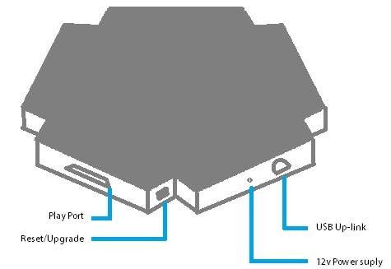

Setup

The 4-Play uses HID (Human Interface Device). No drivers are needed or recommended. For firmware builds and updates see the Download Section.

Note: 4-Play does not natively support Xinput. It can do so, however, with the use of 3rd party software (ie. x360ce).

Note: Although a power supply can be used, it is not required. A 12v power supply is completely optional and simply allows the HUB to be self-powered.

Features
• Full Emulation: A wide variety of controllers are fully supported right out of the box. This includes even complex features like the Sony Playstation 2's pressure sensitive buttons or the Sega Dreamcast's VMU. The Compatibility List shows everything currently supported. This list is periodically updated and amended as we expand the Bliss-Box' capabilities.
• Multiplatform: Use your 4-Play on almost any modern operating system. The 4-Play works on Windows, OSX, Linux, Raspberry Pi, most all Android device, and the even the PS3.
• Plug & Play: The 4-Play does not need software drivers to be installed by the user. Simply plug the 4-Play in and select your emulator, game, and controller.
• Auto Pause: When the adapter senses the controller has because unplugged, it presses the pause button.
• Hot Swap This feature makes it easy to switch between controllers mid-game. If Auto Pause is enabled (default setup) The 4-Play will pause your game while you switch and you can continue playing when you're ready. The new controller is detected automatically.
• Easy-Upgradable Firmware: The 4-Play can be quickly updated via USB with a firmware file downloaded from our website. This allows new features and controllers to be added painlessly. Each 4-Play controller port has its own firmware chip so multiple firmware versions can be used if desired.
• Global Button Mapping: The 4-Play's internal button mapping is set up so that buttons on different controllers match each other's layouts as closely as possible. This makes Hot Swapping more intuitive. Of course, you can remap the inputs any way you like in your game or emulator. Here are some additional details on the global mappings.
• Force Feedback: Controller rumble works on a wide variety of controllers. The currently supported force feedback controllers are the Nintendo 64, Nintendo GameCube, Sony Playstation , Sony Playstation 2, and the Sega Dreamcast.
• D-Pad-Only Mode: This allows the player to use the D-Pad to play a game which requires the analog stick. To activate this mode, simply hold Left Shoulder, Right Shoulder, and the Select, Z, or Start Button at the same time. This causes the 4-Play to interpret the D-Pad inputs to their corresponding analog stick inputs. You can switch this mode off with the same button combo. This allows you to hot swap to non-analog controllers while playing an analog game. This mode is also controller port specific, so Player 1 on the 4-Play can use this mode while other players are in normal mode.

• Button Rotation: This mode rotates the right-side inputs on a 4-way button controller 90 degrees counter clockwise. Very handy if you prefer the Sony Playstation set up and this goes hand-in-hand with the global mapping. If you don't like the way the mapping works when going from the Nintendo Entertainment System to the Super Nintendo Entertainment System, try this feature. To activate it, simply press all face buttons and the Pause/Start Button at the same time. You can switch this mode off with the same button combo.
• Single-Player Mode: The 4-Play can be switched to Single-Player Mode. This will allow for some advance features like using the 4-Play on an Xbox with special firmware, using the 4-Play with a Cronomax adapter, or up-linking to Bliss-Box add-ons.

• Alternative Mapping: The 4-Play can now be mapped to Sony Playstation 3 mode, Xbox 360 mode, Xbox One mode, or normal mode. To activate these modes, simply hold the two main buttons (i.e. A +B ), the Start button, then use the D-Pad to pick a mode. Up = Normal Mode; Down = Sony Playstation 3 Mode; Left = Xbox 360/One Mode.

• Developer API: The 4-Play features an API with which emulator developers can communicate directly with the 4-Play and transfer data. This allows native support for the 4-Plays advanced features. For example, developers can use the API to see exactly which controllers are currently connected to the 4-Play for display on the screen or automatic custom remapping. They can natively support saving to the controller's attached memory card or even write images to the Dreamcast controller's LCD screen. Support for the GameCube's Gameboy Advanced Link can be added. The possibilities are endless. To toggle this mode, hold Left Shoulder, Right Shoulder, D-Pad UP, and the Pause/Start Button all at the same time.

The 4-play has many cool features you can program. Each feature has its own enable/disable code. Since Firmware 1.56 the 4-play now has the ability to save these features. To save the current state of these modes press the following combo: Hold Start + Two Main Buttons (i.e. 1 and 2 or A and B for 3 seconds..
Quick Reference Firmware 1.51 or higher
D-Pad-Only Mode: Left trigger + Right Trigger + select or Z or Start
Button Rotation: All face buttons + Select or Start
Firmware 1.56 or higher
Alternative Mapping: Two main Buttons + Start, then D-Pad direction to set mode, Up = Normal Mode; Down = Sony Playstation 3 Mode; Right = Xbox 360/One Mode; LEFT = Arcade Mode (available since 1.57).

Modes:
Sony Playstation 3 – Mimics a PS3 controller layout. Start + select, is the HOME button.
Xbox 360/One - Mimics a XBOX controller layout. Start + select, is the HOME button.
Arcade – This mode is for arcade setups. All buttons map in an 6 button arcade like style and all d-pad controllers without analog will send the d-pad as digital buttons.
Normal – This is the normal mode best set up for running emulators.

Disable/enable Auto Pause: Hold Start for 6 seconds.

Controller Detection

In general, the 4-Play is capable of detecting your controller type within one to three seconds of it being connected to your system via USB or when changing controllers. With the exceptions listed below, you should not press any buttons during this period or while connecting your controller. Plug in your controller of choice and then plug in the 4-play via usb. Wait for the USB tone without pressing any inputs. If verification is needed, open your control panel in Windows and navigate to the controller section to ensure it is attached and working.

Atari, Mattel Intellivision, and similar controllers have no active electronics. These controllers are merely switches, one for each button. There is no way to detect such a device unless you hold down a button during connection. If unable to detect the controller type, 4-Play defaults to the Atari standard. The following inputs must be held down while connecting specific controllers:

Third-Party Sega Genesis 6-Button: Start Button (Not require in all cases)
Mattel Intellivision: Either of the top shoulder buttons
ColecoVision: Right or Purple Button
Bally: Trigger
How-To

Playstation Pressure
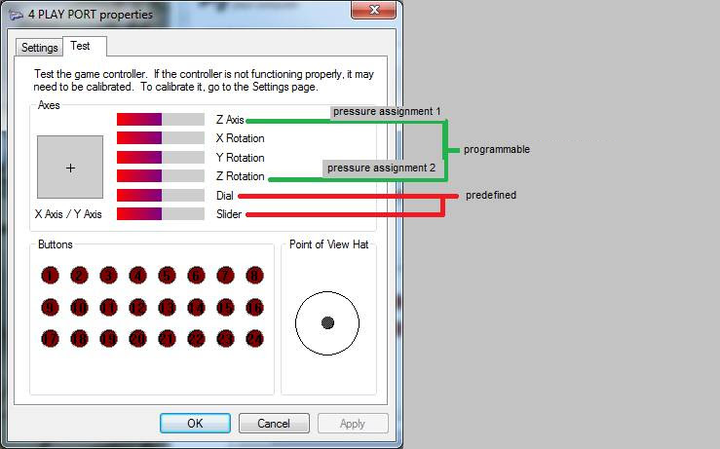

In addition to the analog sticks, HID allows four inputs to be assigned pressure sensitivity. By default, 4-Play enables pressure sensitivity for the L2 and R2 buttons. You may define an additional two pressure sensitive buttons by pressing Start + Select + L3 (or R3)+ by the button you wish to be assigned pressure sensitivity. L3 is for assignment 1 and R3 for assignment 2.
Single-Player Mode

The Xbox won't work with the 4-play in 4-Player Mode. The white arrow in this image indicates the port that becomes active in Single-Player Mode. The mode is toggled via the DIP switches on the base of the 4-Play unit as follows:

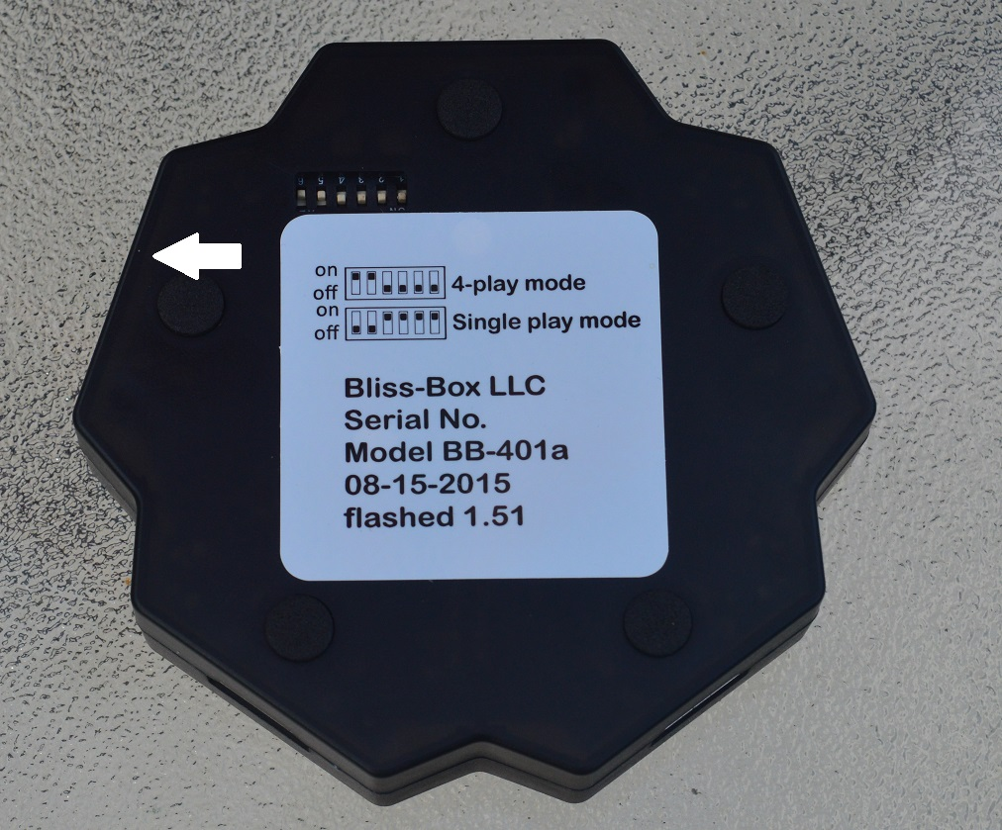

Atari Paddle Modes

Paddles have three modes, as follows:

Atari Mode: The paddles will act just like the paddles do on the Atari system with each paddle having an associated analog represented by the slider/dial on the USB HID. Player 1’s buttons show as right movement of an Atari Stick and Player 2’s shows as left movement. This works great for stellaX (3.3 and above only). Paddles do not work well as a mouse because they are limited turning devices, unlike a spinner or dial.
For proper detection, ensure paddles are neither fully left nor fully right.
Stick-Move Mode: This is a special mode that does not support two paddles at once. Player 1's button works but not the paddle while Player 2 functions normally, only with paddle turns simulating joystick movements.
Press and hold Player 2’s button when plugging in the USB.

Stick-Match Mode: Same as Atari Mode but outputs to the X-axis instead of to the Dial.
Press and hold both Player 1`s button and Player 2`s button when plugging in the USB.
Firmware Upgrade

The Reset/Upgrade Buttons are multi-purpose. There is one beside each port on the 4-Play. During normal use it works as a reset button, forcing the unit to re-detect the connected controller. If you hold it down, however, it tells its 4-Play port to go into Upgrade Mode. When you release it, it will go back to normal operation.

Resetting the device is typically not necessary. You can always just unplug the controller you`re using and plug in the new controller. However, if the controller you plug in does detect immediately, simply leave it connected and press the Reset/Upgrade Button once. Unplugging the USB also resets the device.

To upgrade firmware, you must first hold down the Reset/Upgrade button. The first time you do this, your system will indicate, "BLISS-UPDATOR hardware found." Open HIDBootFlash v.1.0, found here.

Step 1:With the Reset/Upgrade Button still held down, select "Find Device."

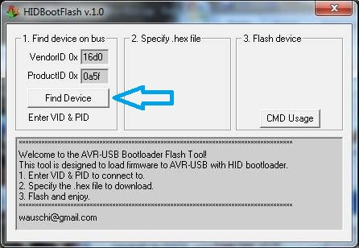

Step 2:Specify your firmware .hex file.

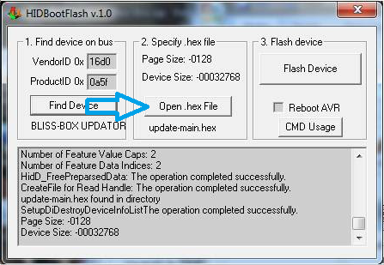

Step 3: Still holding the Reset/Upgrade Button, click "Flash Device."

Caution: Do not release the Upgrade Button during firmware flash as you may cause a bad flash and be forced to re-flash the port.

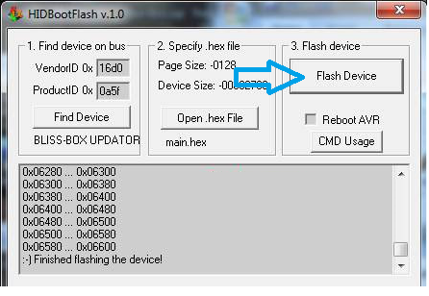

Step 4: Release the Reset/Upgrade Button to return to normal operation.

Troubleshooting

General trouble shooting. HID is, for the most part, trouble free. Use normal USB troubleshooting techniques to fix any devices that aren't correctly detected. Unplugging the USB, using another port, or restarting the computer is a good place to start. Please contact Support if a specific emulator is giving you trouble or if you still have issues after following the steps below. The forums are another fast and helpful resource.

Third-Party controllers. In general ,you should have no problems while using third-party controllers. However, they are not always designed the same way as the original manufacturer intended. Some might work on the console but with the 4-Play. For example most Mad Catz Nintendo 64 and Nintendo GameCube controllers work but Mad Catz Sega Dreamcast controllers don't. See the compatibility list for more info.

FAQ
Will 4-play work with my emulator?
Unless an emulator does not support HID, it will work. Bliss-Box does not have control over what an emulation author does, however. As long as they fully support HID, everything will work. Dev teams are quick to resolve issues to ensure full functionality. Some older, Dos based emulators do not work with HID. If you have trouble, contact the emulator author and work with them to get it resolved.

Why aren’t some of my buttons working?
A1. Reset the device.
A2. Is this an official gamepad? (contact us).
A3. Some connectors may need replacing. If you feel the connector is faulty, it is replaceable (contact us).
A5. Does the controller work? Old controllers can be dirty or worn out, test on the console.
Why am I getting random nonsense inputs?
A1. The firmware will attempt to auto detect, so make sure your controller is plugged in when you connect the USB.
A2. Is this an official gamepad? (contact us).
A3. Some Sega Dreamcast and Nintendo GameCube controllers might act this way (contact us).
A4. Reset the device.
Why isn’t my Coleco number pad working?
Reset the device, the adapter is in Atari Mode. Hold down the right trigger (SAC purple button) when plugging in the USB.
My SNES or NES thinks makes the X go left when I hit a button, what's wrong?
Reset the device, the adapter is in Atari Mode.
Why aren't my sega X Y Z buttons working?
The controller may be in 3-Button Mode. Hold down the Start button and reset the 4-Play.

Why do I have more buttons on the HID window than my controller has?
This is normal; it’s part of saving space on the microchip. It will not affect gameplay or setup.
Why does my Guitar Hero guitar have the left button (button 13) held down?
Keep the Guitar connected, and reset the device. It’s in normal Sony Playstation mode.

What do I do if my controller works but it isn't included on the Compatibility List?
Great! Use the forums and tell us what it is and the model so we can add it!

If my controller isn't on the Compatibility List, will it work?
It might! Check the forums or contact us. If it doesn't, we can probably update our firmware so that it does!

Can you make my control work even if it's listed as not working?
Contact us! We're willing to bet we can make it work and add it to our firmware.

How can I force Windows to detect my ports in a specific order?
If your ports aren`t being detected by Windows XP in the order you`d prefer simply go to the forum, look under Tools, and download JoyID. This will allow you to change HID IDs as you see fit by following the included documentation.

For any OS that does not work with JoyID, the only solution currently is to flash 4 separate firmwares to the 4-play, one for each player. There is a unofficial project by Atarigalore, a trusted friend of Bliss-Box, that does this but it is not officially supported.

